Practical 1
Creating an AWS Account and Applying MFA

Aim
To create an Amazon Web Services (AWS) Free Plan account, sign in to the AWS Management Console as the root user, and secure the account by enabling Multi-Factor Authentication (MFA)

Part A: Creating the AWS Account
The screenshots below show every stage of the sign-up and first login, with a description of what happens in each.
Step 1: AWS sign-in page (IAM user)
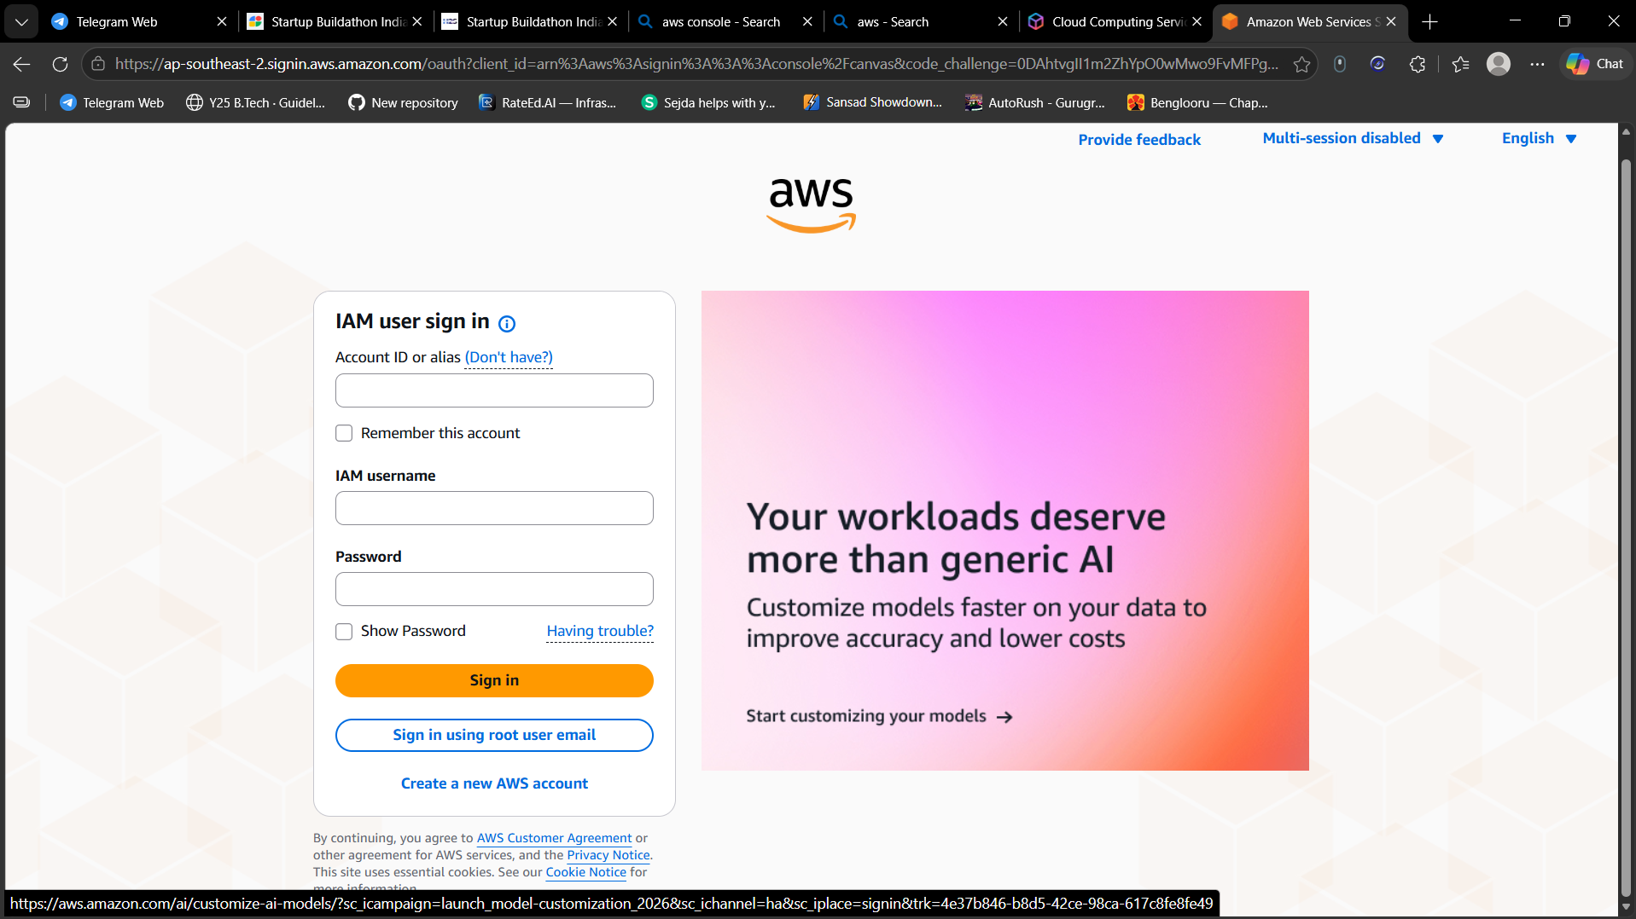
Figure 1
This is the starting point. The AWS sign-in page opens with the IAM user sign-in form (Account ID/alias, IAM username, password). Since no account exists yet, the options at the bottom, "Sign in using root user email" and "Create a new AWS account", are used to begin registration.
Step 2: AWS sign-in page: New to AWS? Sign up
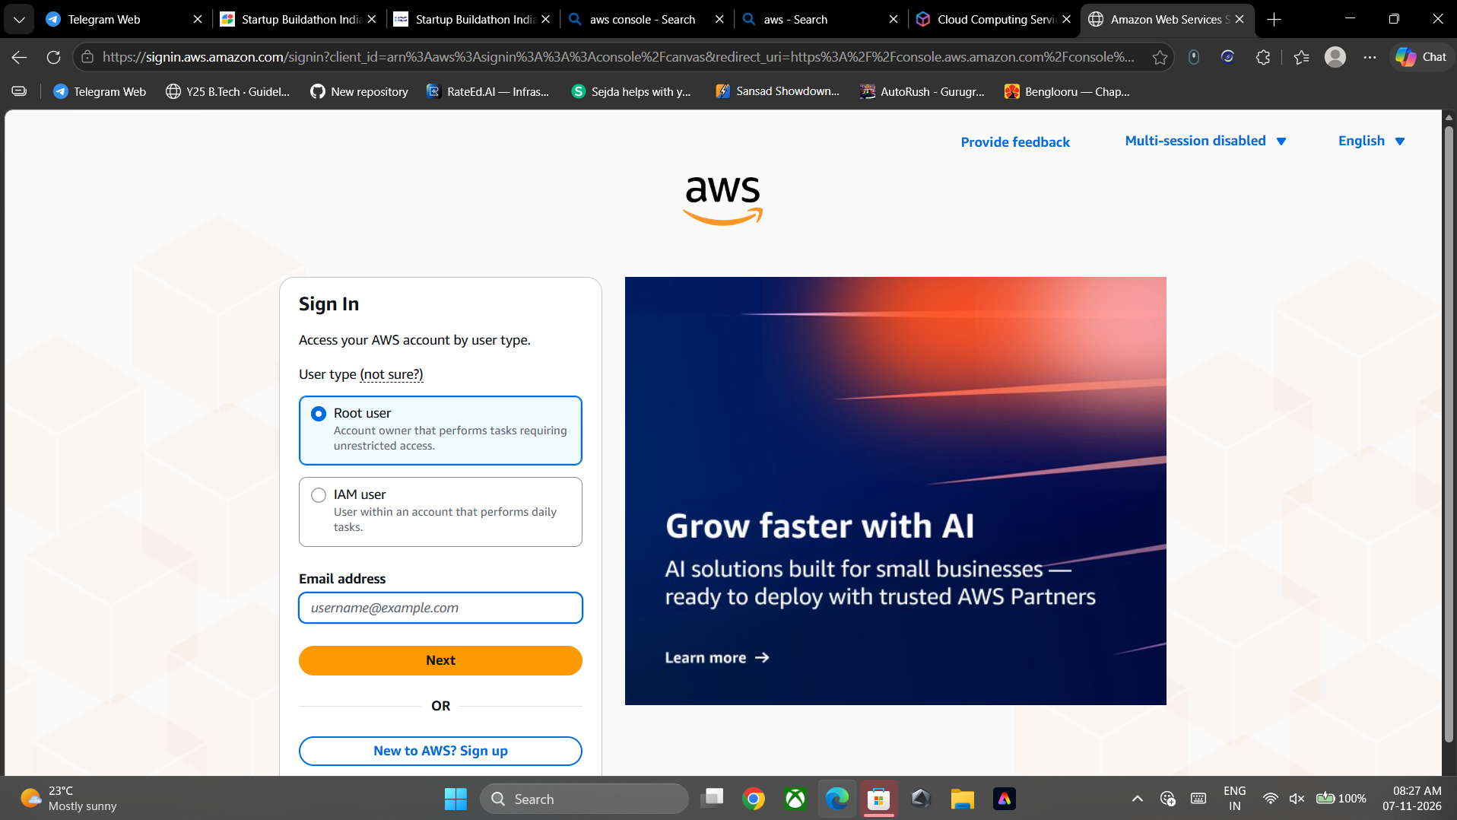
Figure 2
The main AWS sign-in page offers "Root user" and "IAM user" options. Because we do not yet have an AWS account, we click the "New to AWS? Sign up" button to start creating one.
Step 3: Sign up: create root user password
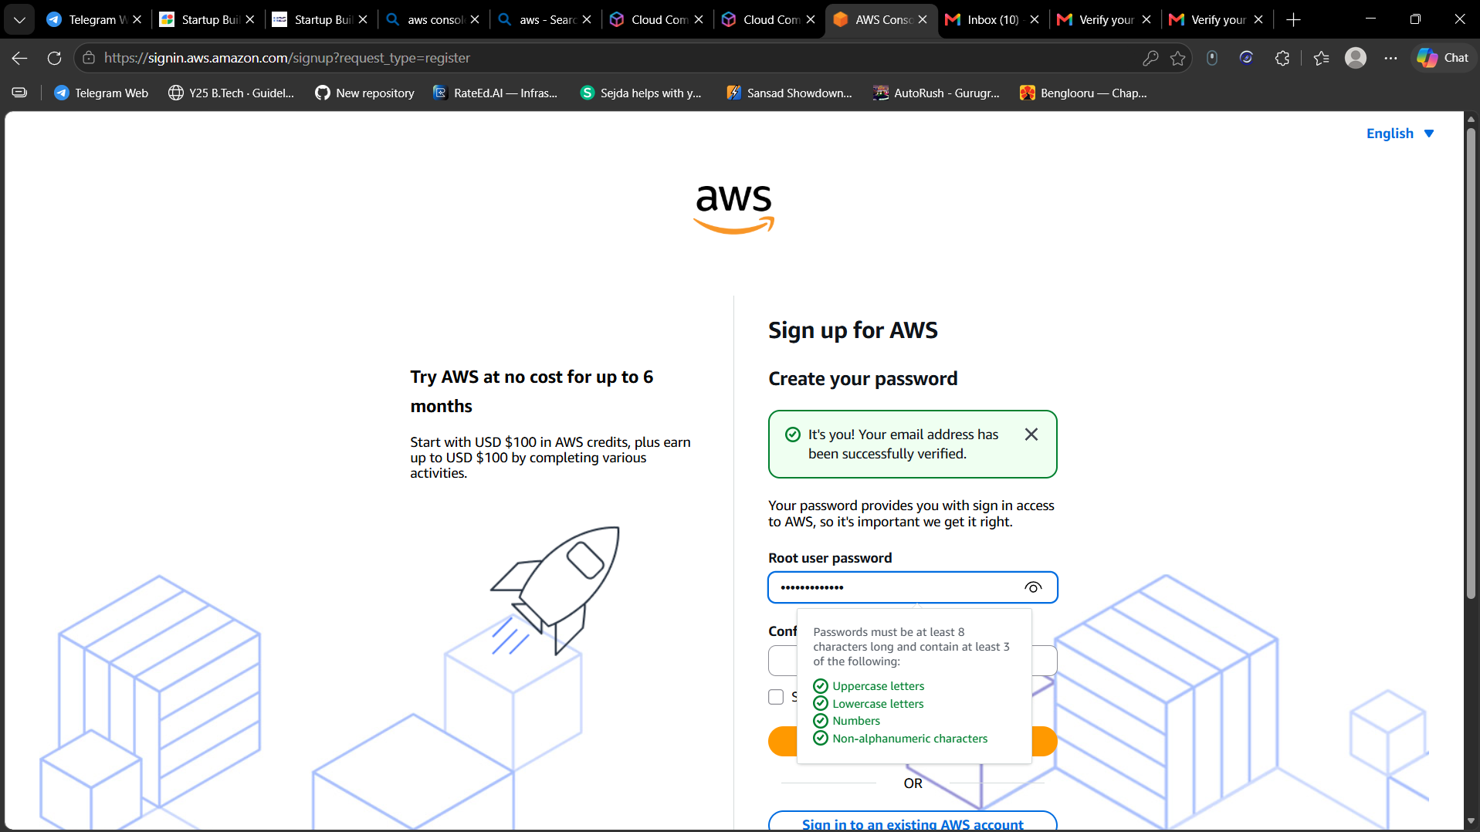
Figure 3
The email address has been verified successfully (green confirmation banner). Now the root user password is created and re-entered in the confirm field. The password hint box shows the rule: at least 8 characters with uppercase, lowercase, numbers and non-alphanumeric characters, and all four checks are ticked green.
Step 4: Sign up: Contact Information
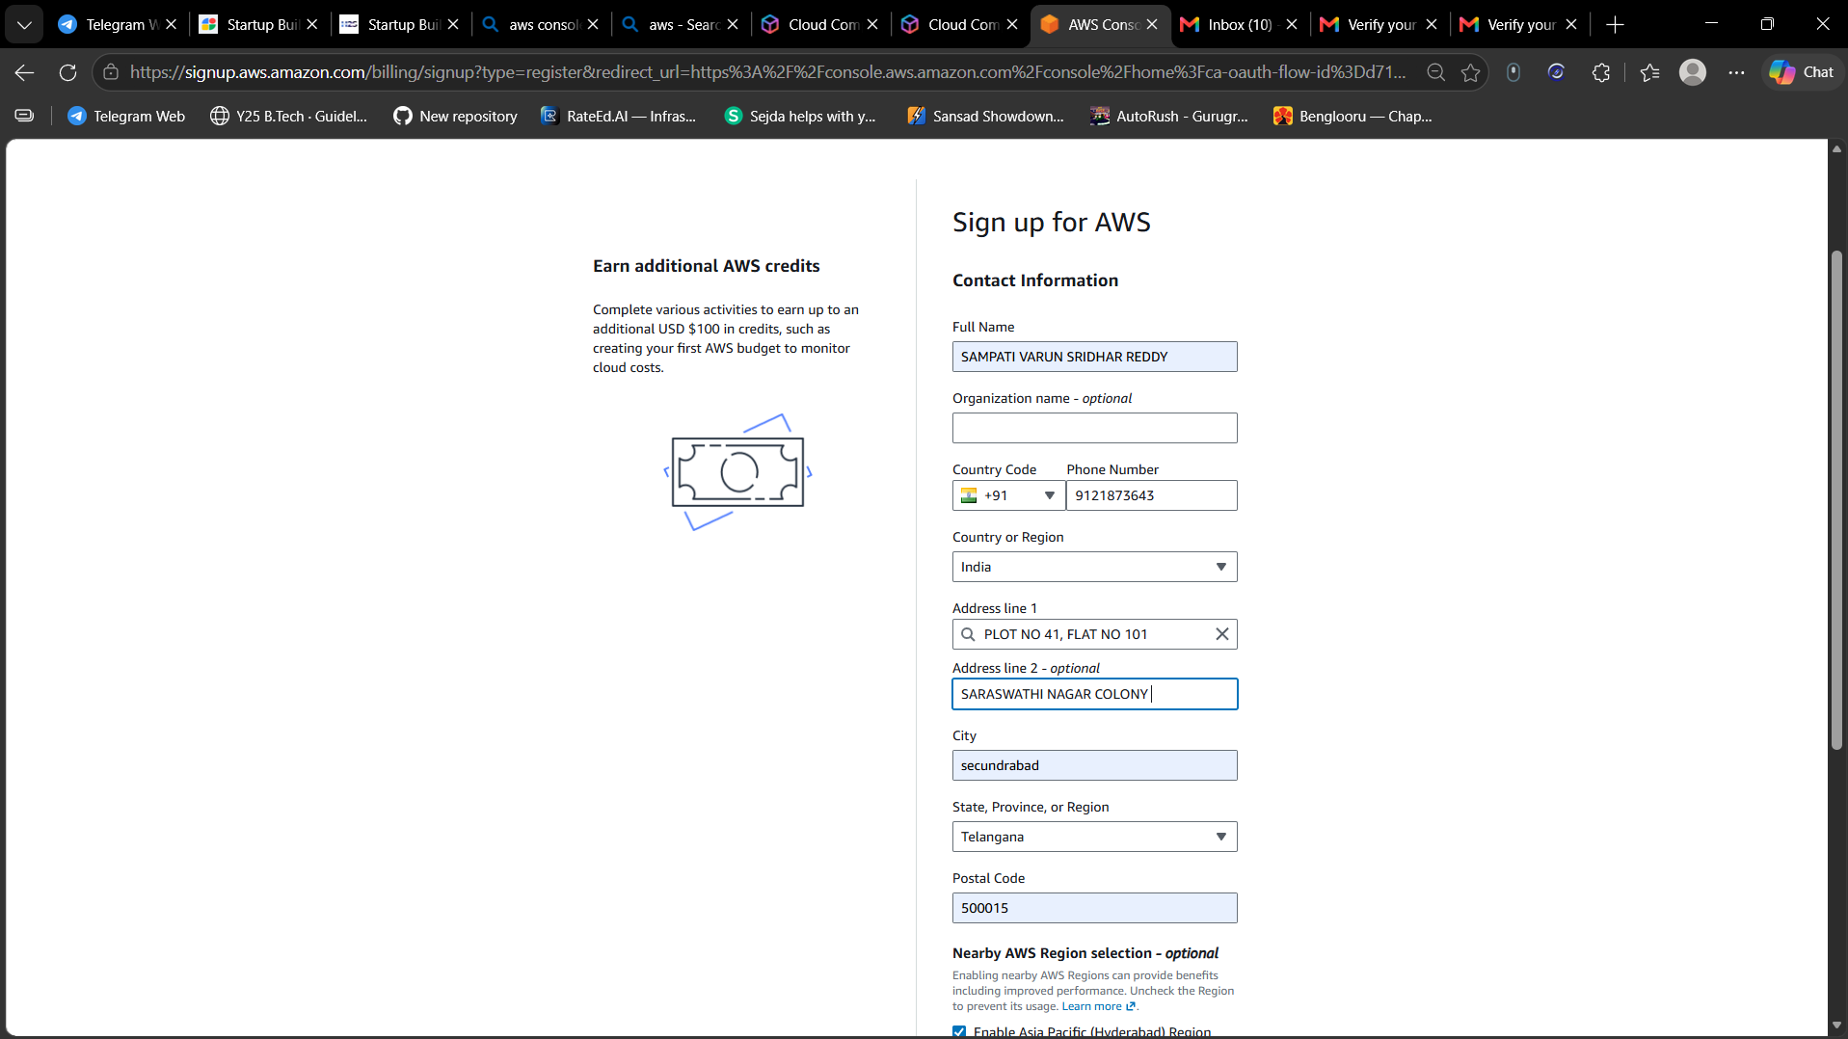
Figure 4
The contact information form is filled in: full name, optional organization name, country code and phone number, country/region (India), address lines, city, state (Telangana) and postal code. There is also an optional "Nearby AWS Region selection" checkbox for enabling the Asia Pacific (Hyderabad) Region.
Step 5: Sign up: Billing Information
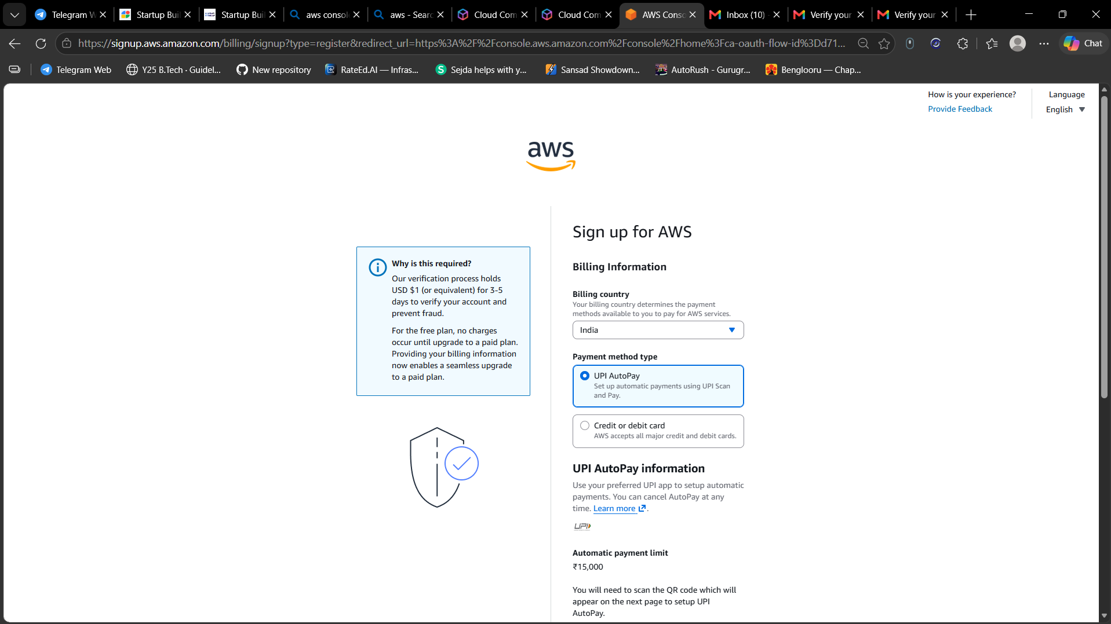
Figure 5
AWS asks for billing information. A note explains that a small verification amount is held (USD 1 or equivalent) for 3-5 days to verify the account and prevent fraud, and that the free plan carries no charges until upgrading to a paid plan. Billing country is India, and the payment method type chosen is UPI AutoPay (credit/debit card is the other option), with an automatic payment limit of Rs. 15,000.
Step 6: Billing address and Continue
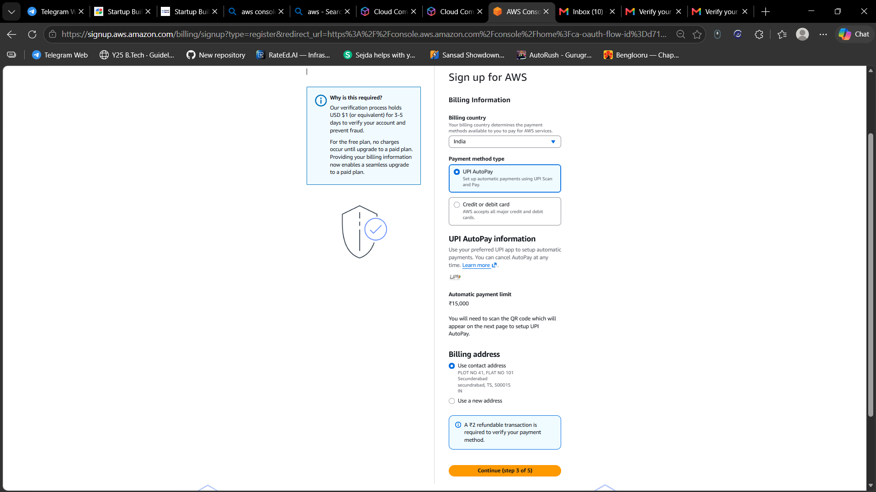
Figure 6
Scrolling down shows the billing address section, where "Use contact address" is selected so the earlier address is reused. A notice says a Rs. 2 refundable transaction is required to verify the payment method. The "Continue (step 3 of 5)" button moves to the next step.
Step 7: Verify your payment method
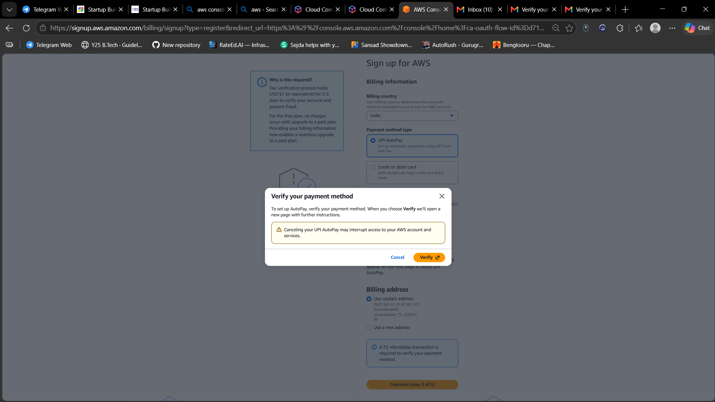
Figure 7
A pop-up titled "Verify your payment method" appears. It explains that to set up AutoPay the payment method must be verified, and that clicking "Verify" opens a new page with further instructions. It warns that cancelling UPI AutoPay may interrupt access to the AWS account and services.
Step 8: Amazon Pay: scan QR to pay Rs. 2
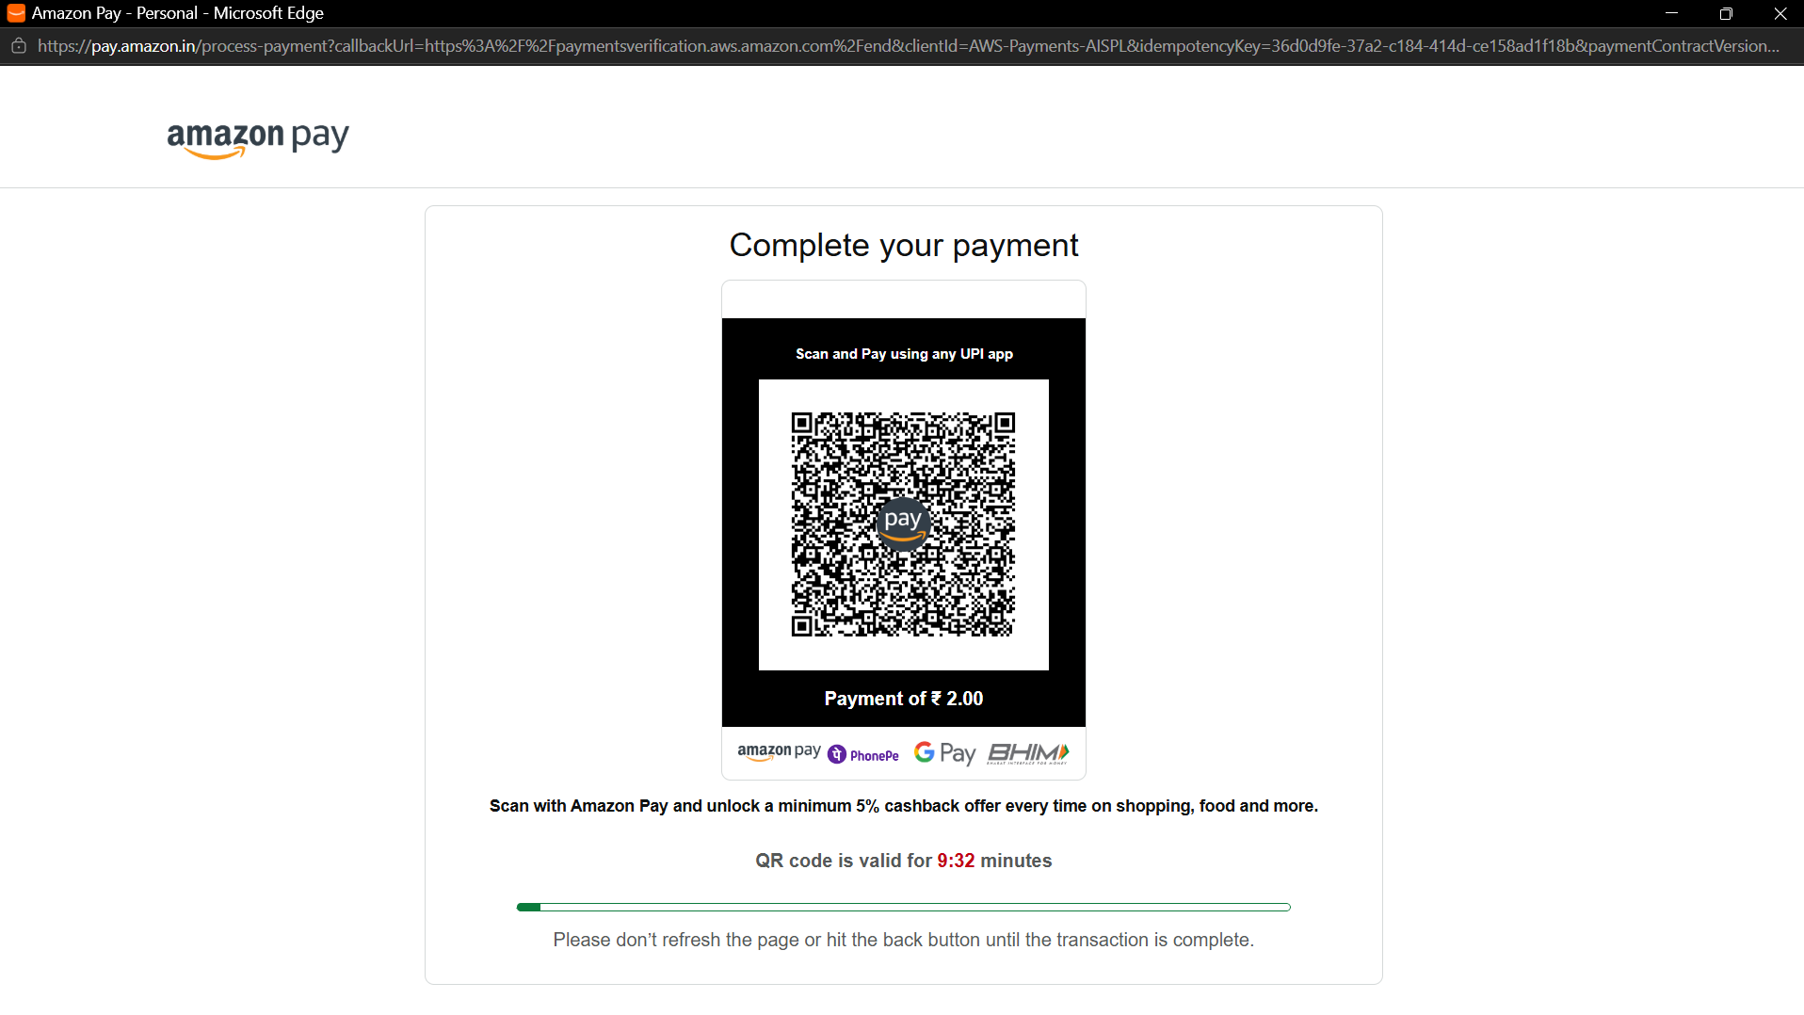
Figure 8
The Verify button opens an Amazon Pay page showing a UPI QR code for a payment of Rs. 2.00. The QR code is scanned with any UPI app (Amazon Pay, PhonePe, Google Pay, BHIM) and the payment is approved. The code is valid for about 10 minutes, and the page must not be refreshed until the transaction completes.
Step 9: Confirm your identity: purpose and ownership
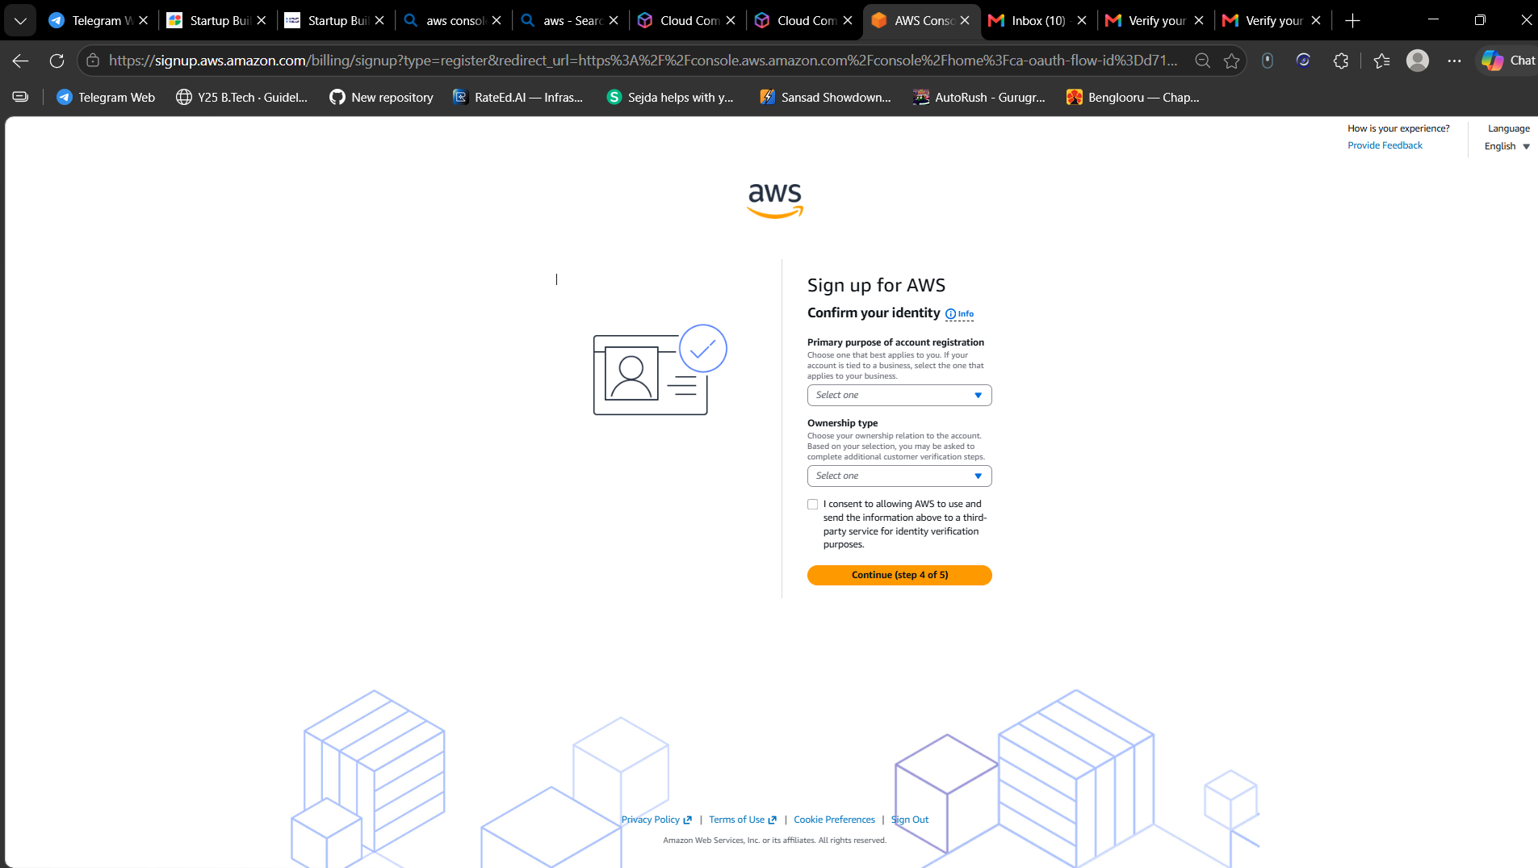
Figure 9
Step 4 of 5. AWS asks for the primary purpose of the account registration and the ownership type (dropdown lists). The user also ticks a consent box allowing AWS to send this information to a third-party service for identity verification, then clicks "Continue (step 4 of 5)".
Step 10: DigiLocker consent page
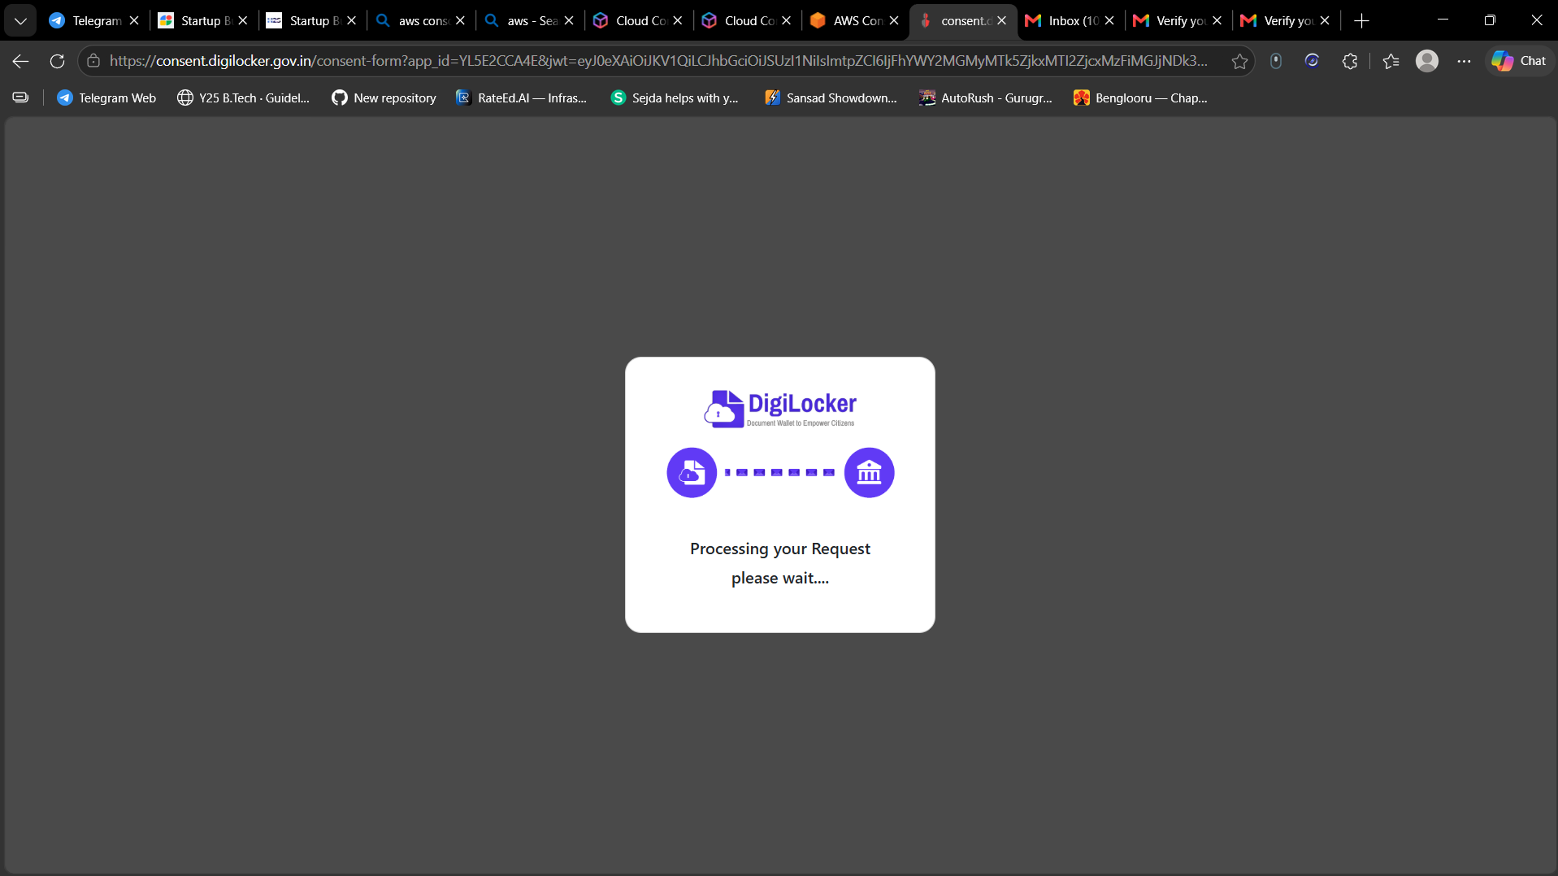
Figure 10
As part of identity verification, the browser is redirected to the DigiLocker consent page (consent.digilocker.gov.in). It shows "Processing your Request, please wait..." while DigiLocker connects to the verification service.
Step 11: Confirm your identity: phone verification
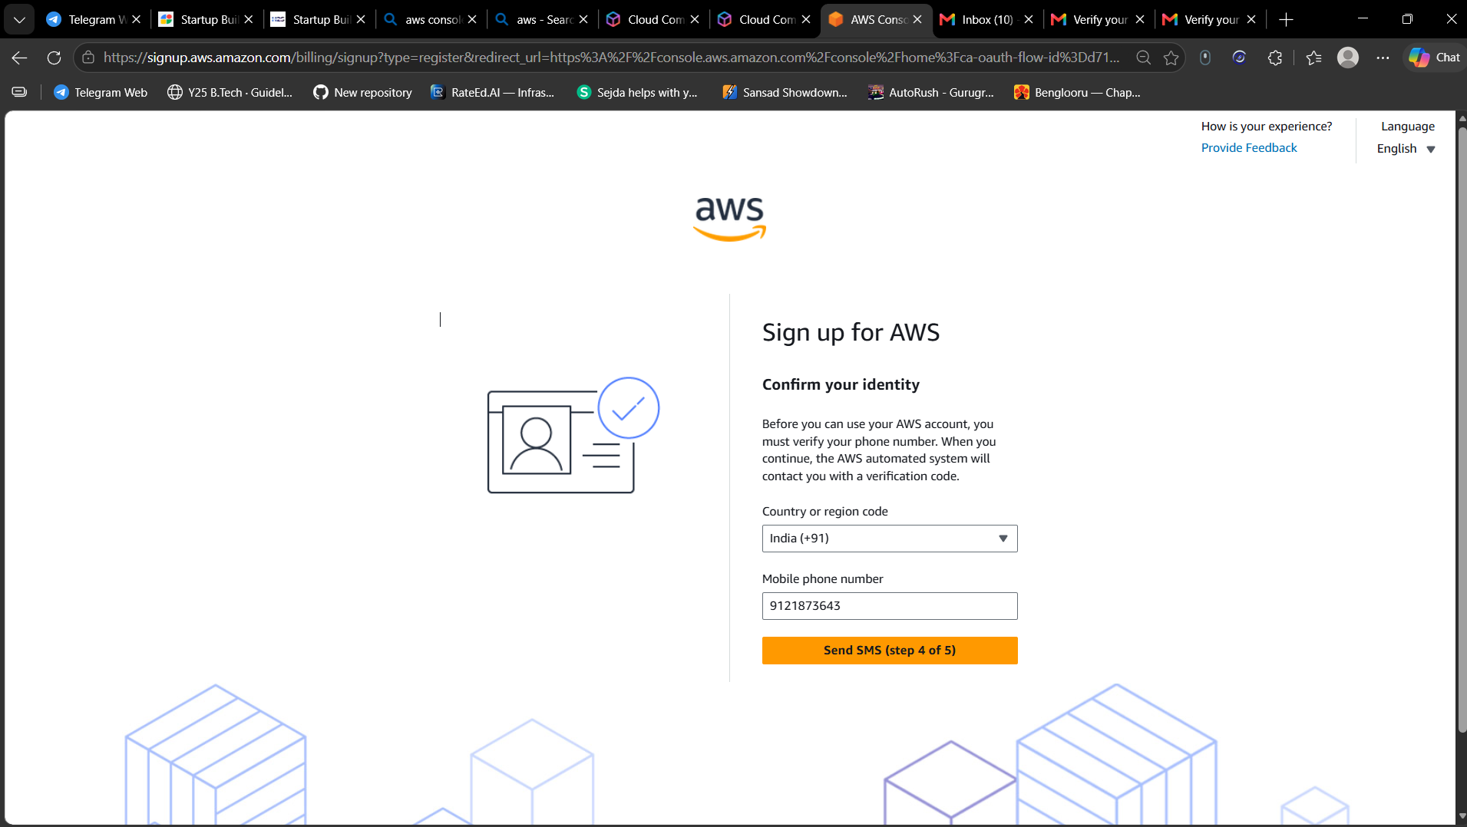
Figure 11
Back on AWS, the page asks for a mobile phone number to verify identity. The country code is set to India (+91) and the mobile number is entered. Clicking "Send SMS (step 4 of 5)" makes the AWS automated system send a verification code to the phone.
Step 12: Setting up your AWS account
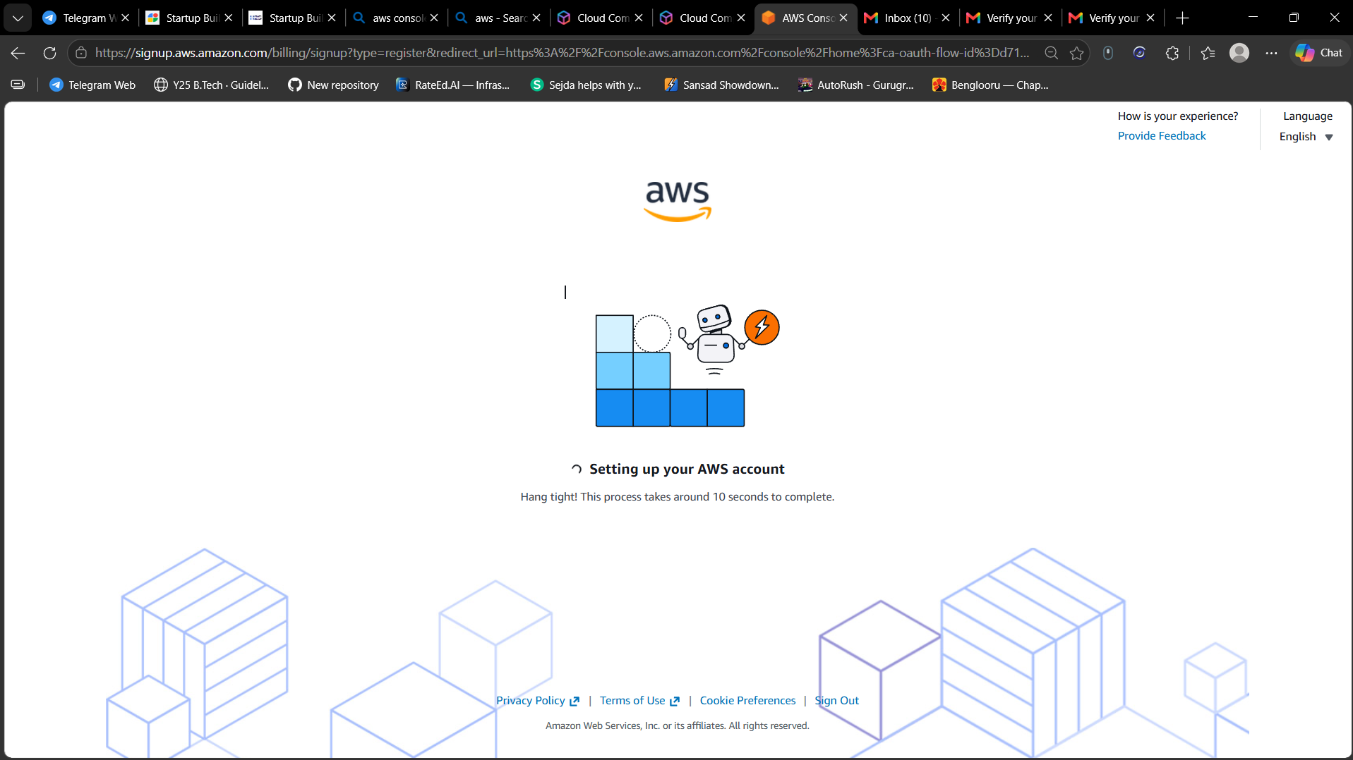
Figure 12
After all verification steps are completed, AWS shows the "Setting up your AWS account" screen. The message says the process takes around 10 seconds. The account is being created in the background.
Step 13: AWS Management Console home (first login)
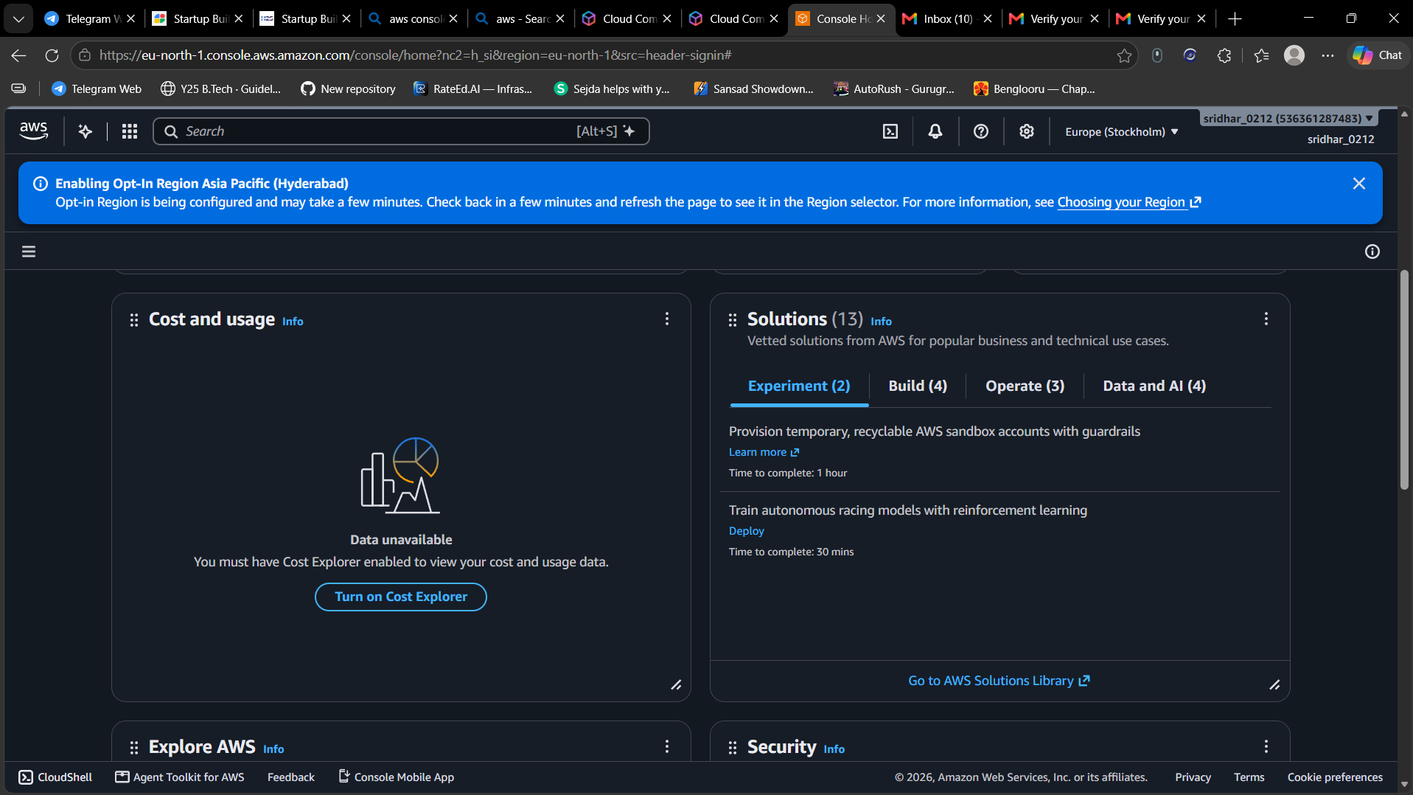
Figure 13
The account is created and the AWS Management Console opens. The top bar shows the account name and the selected Region (Europe, Stockholm). A blue banner says the opt-in Region Asia Pacific (Hyderabad) is being enabled and may take a few minutes. The dashboard widgets (Cost and usage, Solutions, etc.) are visible.
Step 14: Console home with free plan status
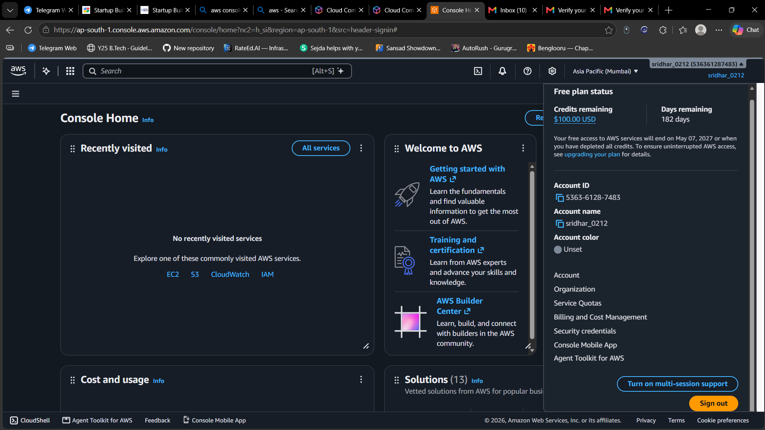
Figure 14
The Region has been switched to Asia Pacific (Mumbai). The account menu shows the "Free plan status": USD 100.00 in credits remaining, 182 days remaining, and that free access ends on May 07, 2027 or when the credits are used up. It also lists the account name and menu links such as Account, Organization, Billing, and Security credentials. Security credentials is the page used later to assign MFA.
Step 15: Sign in as Root user
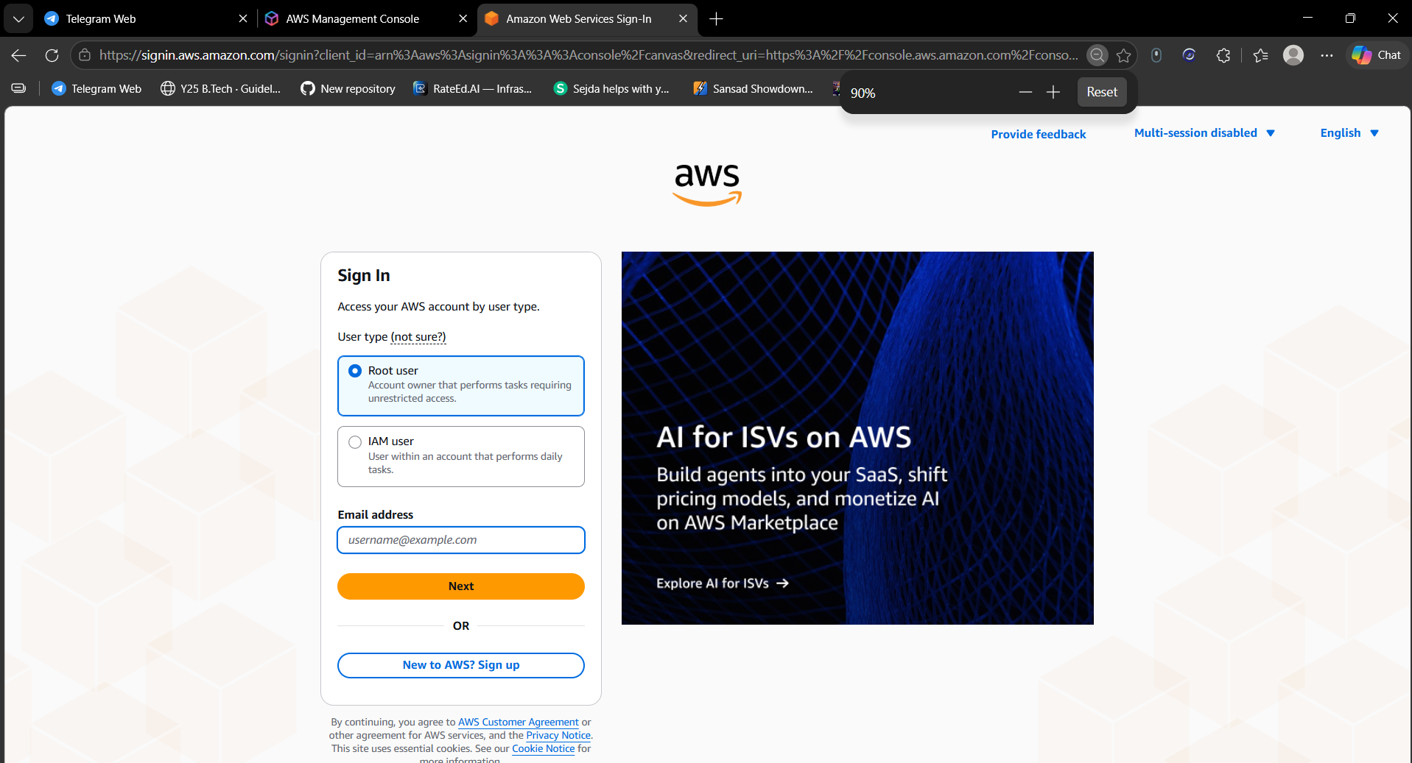
Figure 15
To log in again, the AWS sign-in page is opened, "Root user" is selected, and the registered email address is entered. Clicking "Next" continues to the password step.
Step 16: Security check (CAPTCHA)
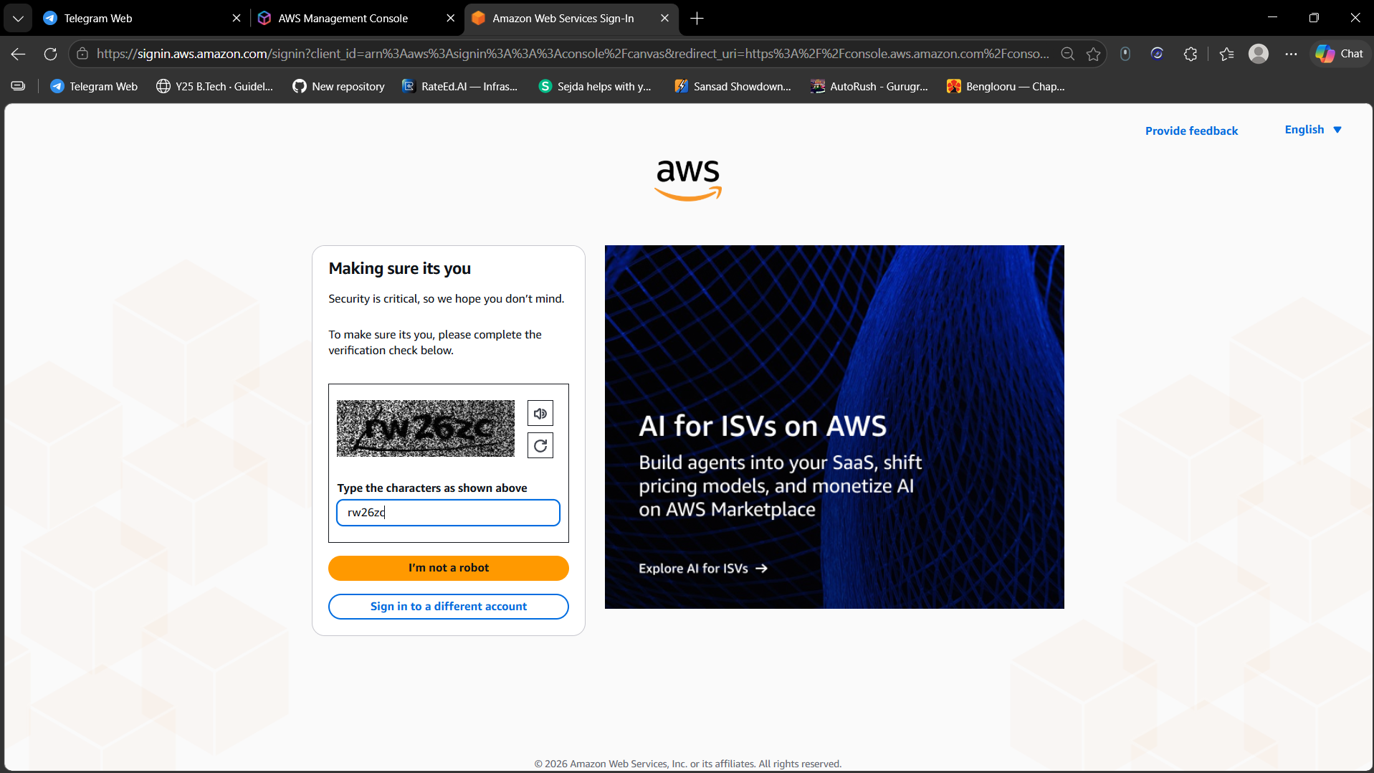
Figure 16
AWS shows a "Making sure it’s you" security check. The characters shown in the image are typed into the box and "I’m not a robot" is clicked to prove the sign-in is done by a human.
Step 17: Root user password entry
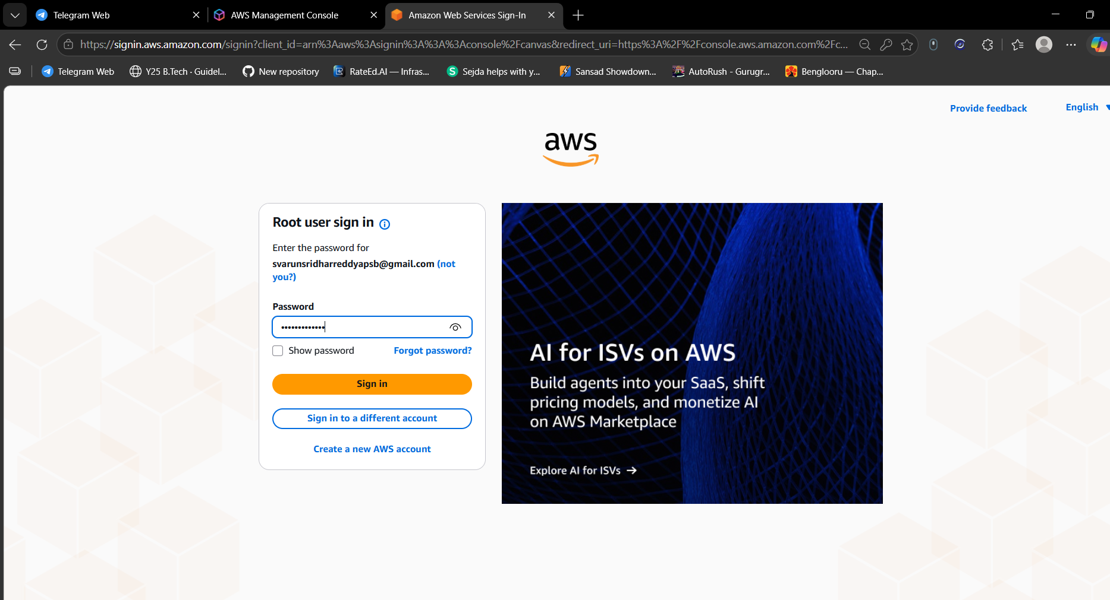
Figure 17
After the CAPTCHA, the root user sign-in page asks for the password of the registered email. The password is typed (masked) and "Sign in" is clicked to enter the AWS Management Console.

Part B: Applying MFA (Multi-Factor Authentication)
MFA adds a second layer of security. Along with the password, the user must enter a changing 6-digit code from an authenticator app, so the account stays protected even if the password is leaked. The root user account has full control, so MFA should be enabled on it right after sign-up. Figure 14 shows the account menu where Security credentials is found.

Procedure
- Sign in to the AWS Management Console as the root user (Figures 15 to 17).
- Click the account name at the top right and choose "Security credentials".
- In the "Multi-factor authentication (MFA)" section, click "Assign MFA device".
- Enter a device name and select "Authenticator app" as the MFA device type, then click Next.
- Click "Show QR code" and scan it with the authenticator app on the phone (or enter the secret key manually).
- Type two consecutive 6-digit codes generated by the app into MFA code 1 and MFA code 2.
- Click "Add MFA". The device now appears in the list of assigned MFA devices.
- Sign out and sign in again: after the password, AWS now asks for the MFA code, which confirms MFA is working.

Result
An AWS Free Plan account was created successfully. The account received USD 100 in credits valid for 182 days, the root user was able to sign in to the console, and MFA was applied to protect the account with a second verification factor.

Conclusion
This practical covered the complete AWS account sign-up process: email verification, password creation, contact and billing details, payment verification through UPI, identity verification by phone, and the first console login. It also explained how MFA is enabled to improve account security, which is a basic best practice for every AWS account.

